Dinesh S
Emp id : 5491

Task 1: creating kubernetes cluster and run Mysql server in the pod
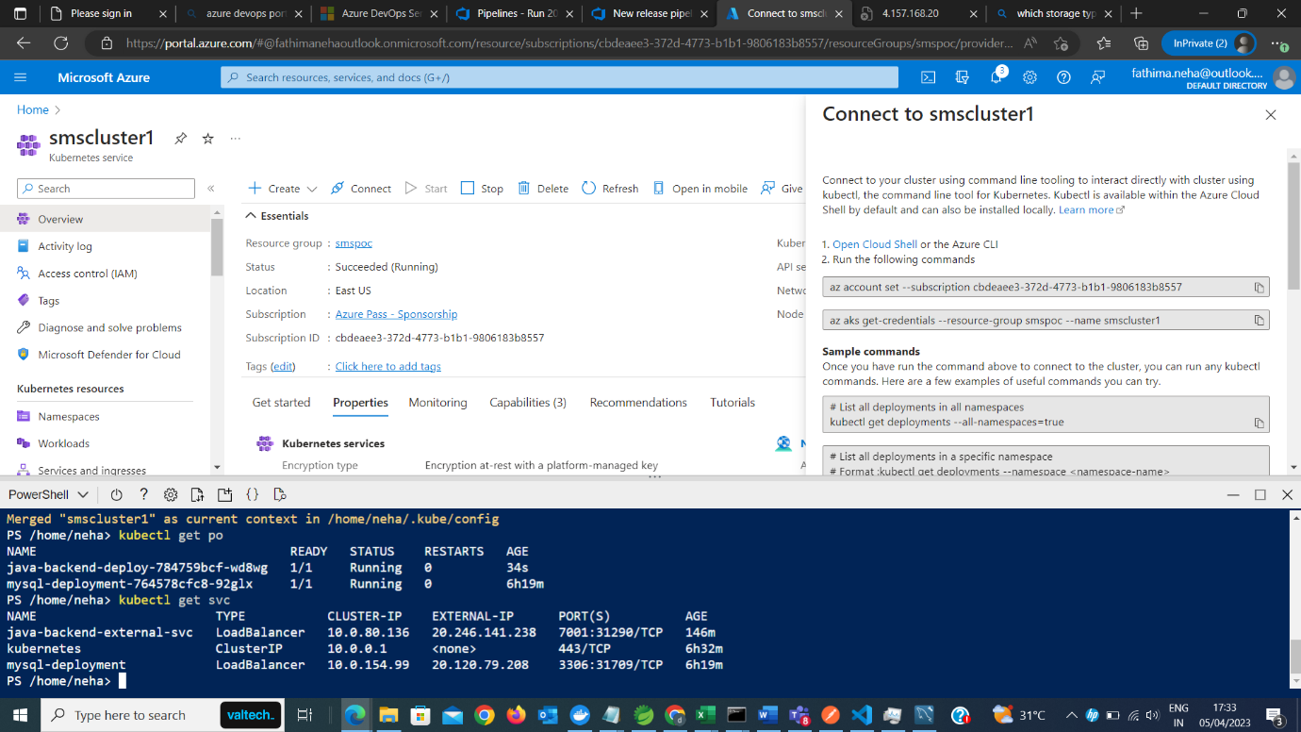

Task 2: connecting with workbench
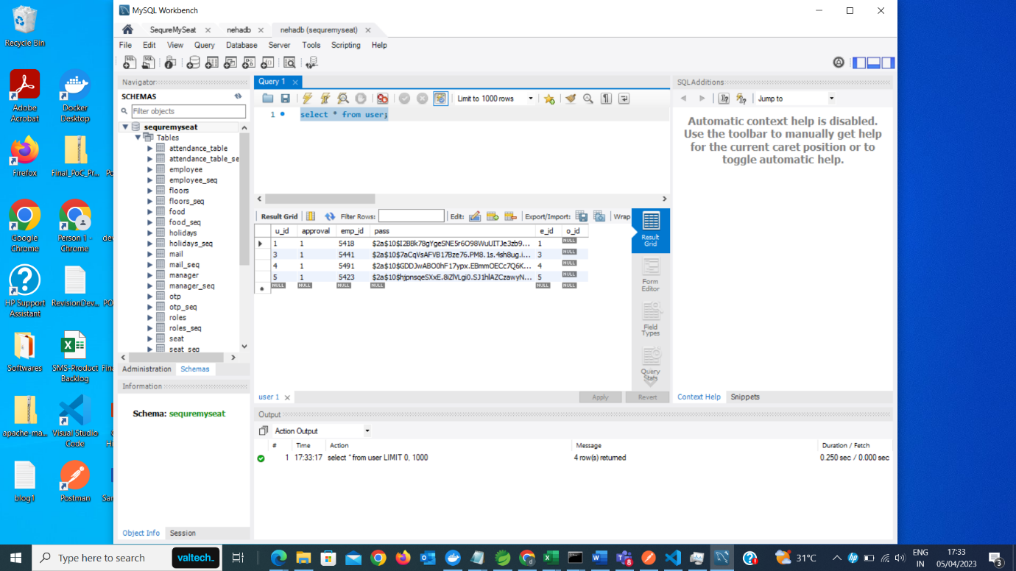
Task 3: setting up service connections
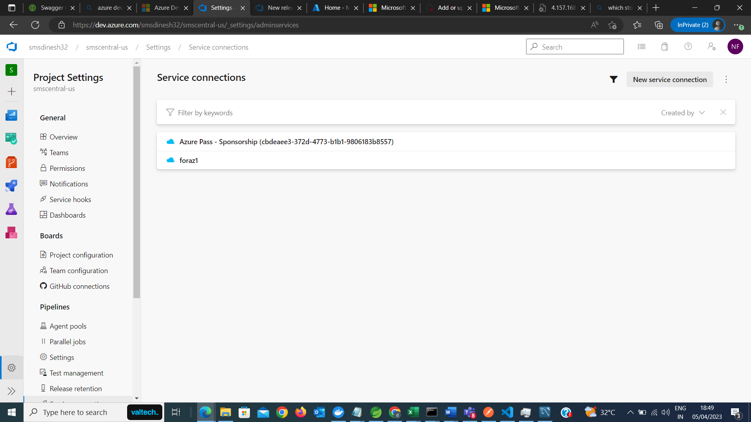

Task 4: CI to run maven build, create docker image and publish into acr
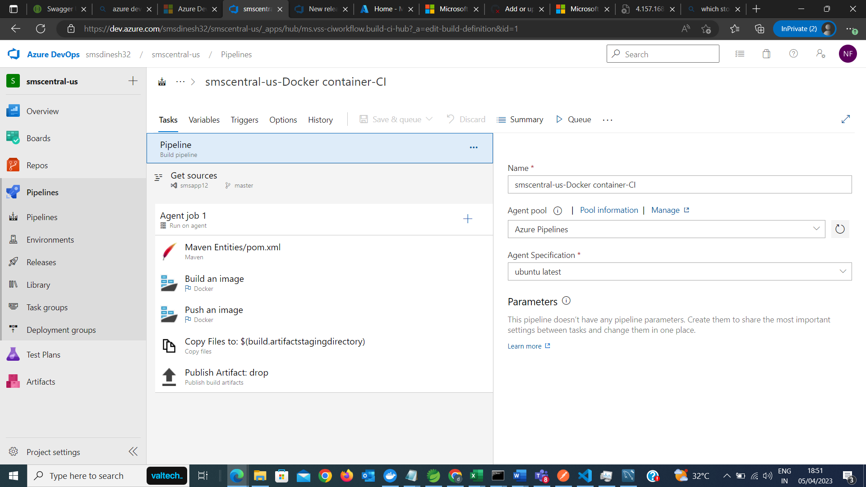

Task 5: Cd to deploy backend code into kubernetes cluster
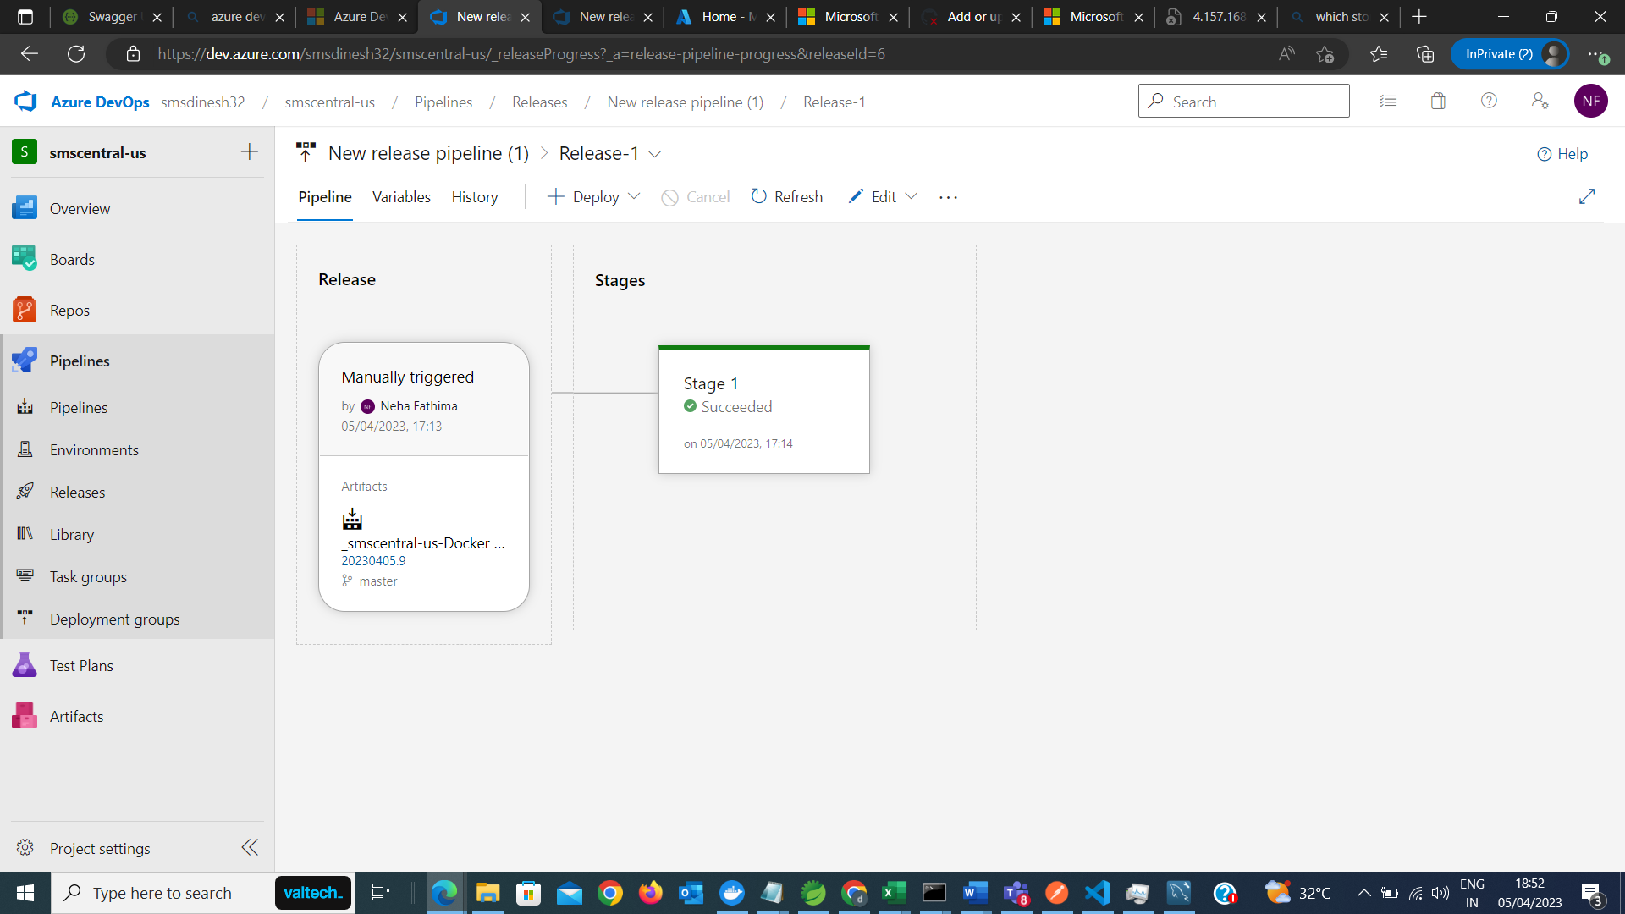

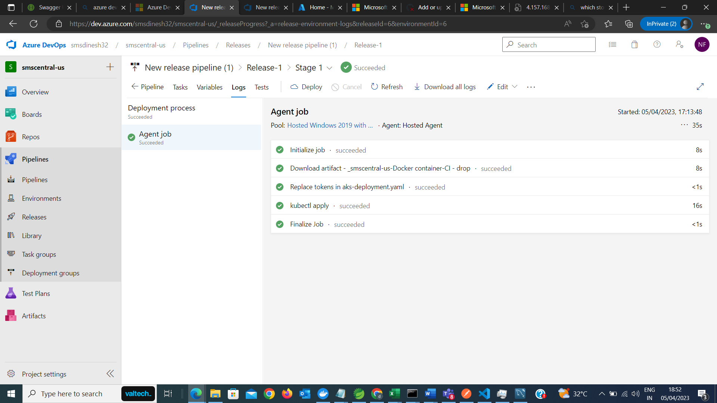

Task 6: Testing the backend api with swagger integrated
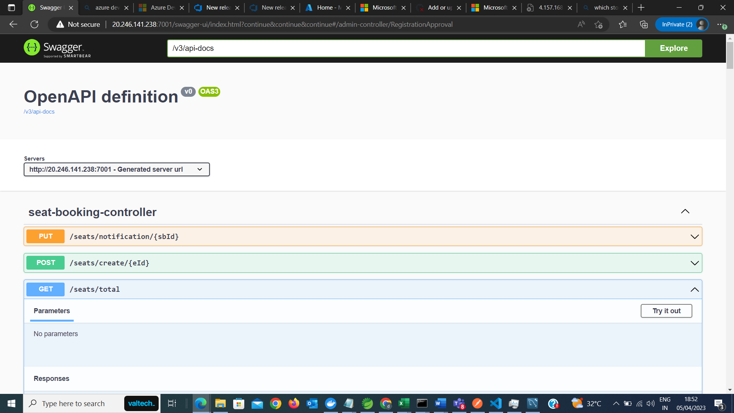

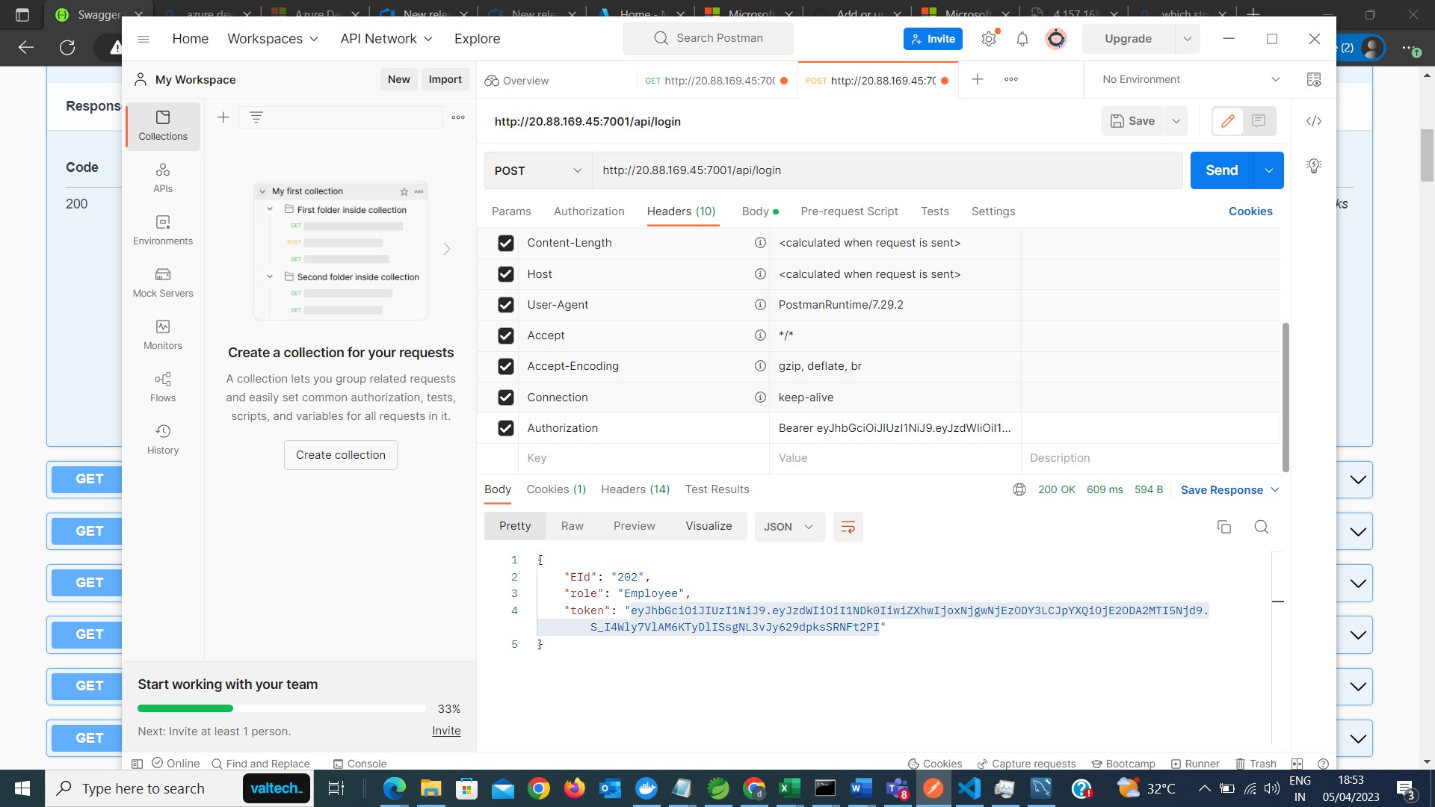

Task 7: testing integration with frontend application is now in progress…

